# Python Installation—Create your Python Environment

## Goal

At the end of this lesson, you should have:

* Chosen a Python environment
* Installed Python, and an IDE if desired
* Modified and run a simple Python program

## Required Reading

Cyber Aces, Introduction to Python, <https://tutorials.cyberaces.org/tutorials/view/3-3-1.html>

## Python

Python is a popular language for security practitioners. Basic Python is simple and easy to understand. There are thousands of available modules to extend Python’s reach into control of hardware, reading disks at hardware level, networking, you name it.

Python is installed by default on most Linux variants (the version is 3.6.x in Ubuntu, 2.7.x in other distros.) In Windows, Python needs to be installed (instructions later.)

## Module Choices

It is hard to know what experience with writing code students have, so I have tried to give you options. You can do either one; the assignments are the same either way.

### Confident students or those with some programming experience

The Python modules available through Cyber Aces (<https://tutorials.cyberaces.org/tutorials.html> ) go quickly through the basics of Python and are enough to get you started. If you wish, you can just read the Cyber Aces Python modules and complete the simple programming assignments.

### Students wanting basic programming materials

The book, *Automate the Boring Stuff with Python* (no starch press) is available online free of cost at <https://automatetheboringstuff.com/> . You’ll need to scroll to the bottom to see the Table of Contents and links to each chapter. Most of the skills we need are in chapters 1 – 4, and 6. You can read those chapters and work the examples in the book to get more assistance on your journey into Python. I still suggest you read the Cyber Aces slides, however.

### Students in between

I have created an index (available in Canvas) that links the Cyber Aces slides to the appropriate portions of Automate the Boring Stuff. You can read the Cyber Aces slides, and as you come across things that confuse you, you can look them up in the online book. This may be the method most of you want to start with.

## Choosing an Environment

There are many ways to write and use Python. Each of these can be done in Linux or Windows.

* Use a terminal Command Line Interface (CLI) and a text editor
* Use Python’s built-in development environment, called Idle
* Use a full-feature development environment

### Terminal and Text Editor

This is the simplest method, and the easiest to use when you move between environments. In this method, I have the terminal with the Python interactive prompt and the text editor side by side. I will often test a line or two of code in the terminal and then paste it into the text editor for safe keeping. Other times I will type a few lines of code into the text editor and then test them in the terminal.  
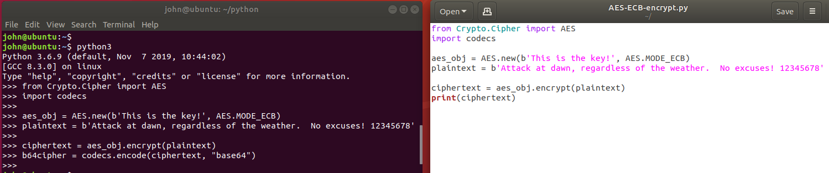

Once I have enough of the code written to have a testable script, I run the entire script in the terminal and begin debugging the errors.

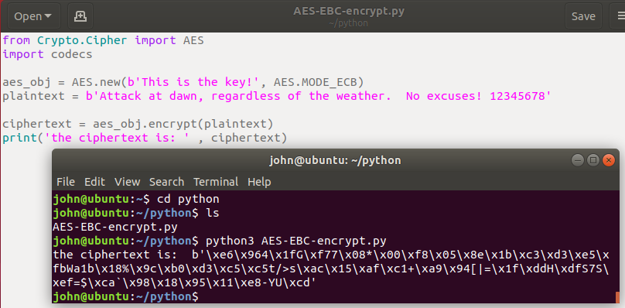

It is important that the working directory of the terminal is the same as the directory where the file is stored; that way you don’t have to specify a path.

In Linux, the gedit text editor understands Python and will color code your scripts. This handy for spotting errors like forgetting to close quotes. The default editor in Windows, notepad, does not do this.

### IDLE

Idle is a simple development interface that comes with Python. It is used by books as the original IDE to teach Python, but it has problems. One problem that drives me nuts is that up arrow does not bring back previous commands; you must use ALT-p. If you are a serious coder, you’ll want to use something other than IDLE. If you just want to try Python without learning an IDE, use IDLE or a terminal and text editor.

In Windows IDLE is installed by default when Python is installed. In Ubuntu Linux, you can install IDLE with apt. <https://www.techrepublic.com/article/how-to-install-the-idle-python-ide-on-ubuntu-desktop-19-10/>   
sudo apt install idle  
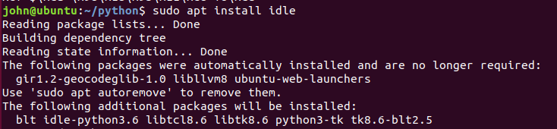  
<snip>

In Linux, make an Idle desktop shortcut by clicking on Activities in the upper-left corner. Type idle, right-click on the IDLE (using Pyth..) icon, and select Add to Favorites.  
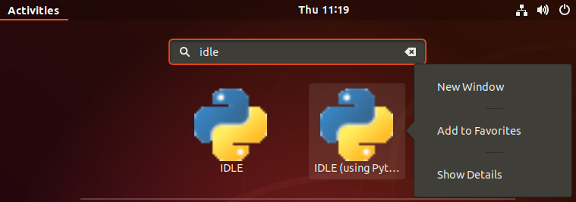

Idle works the same way in both Windows and Linux, so I will use it in all the examples and exercises.

Idle in Linux (Ubuntu 18.04).  
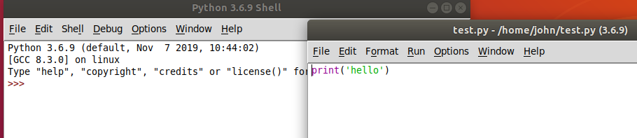

Idle in Windows 10.  
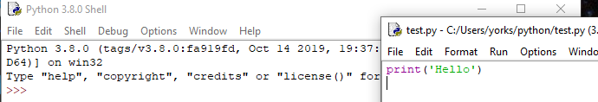

When you open Idle directly (not by opening a Python script in Idle first) you get the Python Shell window.  
Linux  
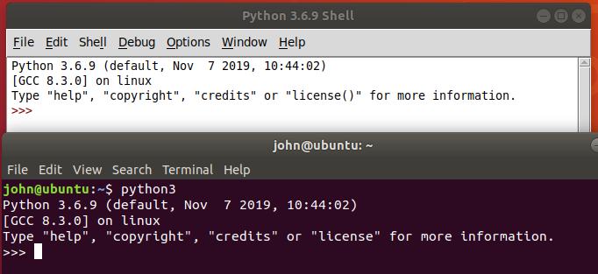  
Windows  
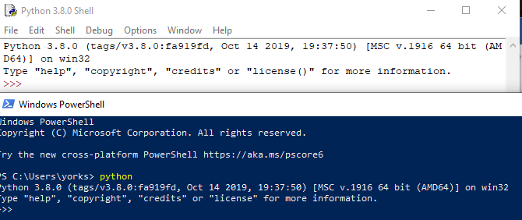

The Idle Shell window is the same as the interactive Python prompt in a terminal, except that it has options along the top.

When you use File > New File in the Idle Shell window (or open an existing file) you see Idle’s Text editor.

You can jump back and forth between the shell and editor just like you would between a terminal and text editor. When you run a script from the editor, it will run in the shell. For more information, see Chapter 3 of *Cracking Codes with Python*.

Idle is a minimal development environment, but it is useable. The most annoying thing for me is that you scroll through previous commands in the Shell window using Alt-P (previous) and Alt-N (next). I would much rather use the up and down arrows.

### Full-featured Development Environment

If you do a lot of work in Python, you will undoubtedly select a better Integrated Development Environment (IDE). You can find several by searching the Internet for “python best IDE”. It takes a while to learn to use a complicated IDE; we don’t have much time to spare so we won’t use a full IDE in this class.

Many of the security people I know use Visual Studio Code, which is a free download. They like it because it supports the other languages they use, so they only need one IDE.

If you will only use Python, the Spyder IDE which is part of Anaconda may be a good choice.

## Installing Python on Windows

Windows users can download Python from <https://www.python.org/downloads/windows/>. This will also install the Idle editor for Python. When you install Python on Windows be sure to check the box to add Python to your path!! It will make life much easier. It is very handy to just type “python” in a terminal and have it work, rather than typing the entire path.

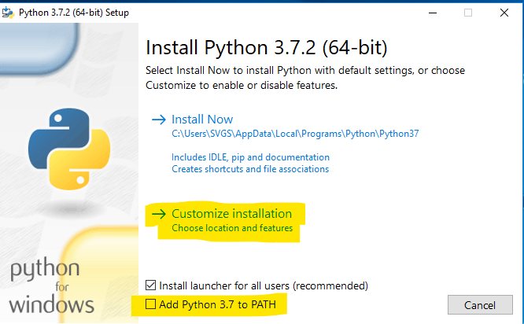

In the custom installation make sure that pip is selected. 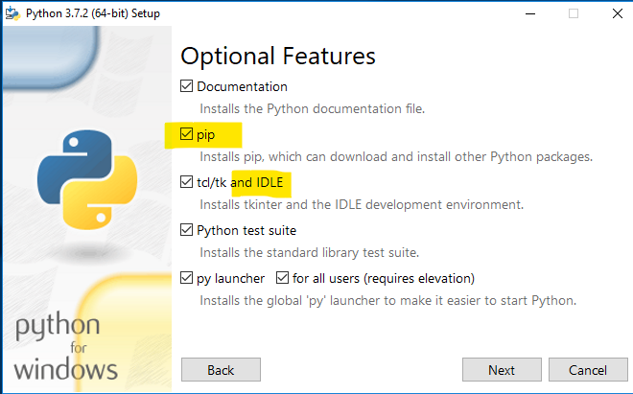

Window has a limit of 260 characters in a file path. Since Python installs itself on a long file path (like C:\Users\SVGS\AppData\Local\Programs\Python\Python37\) the limit can cause problems.  
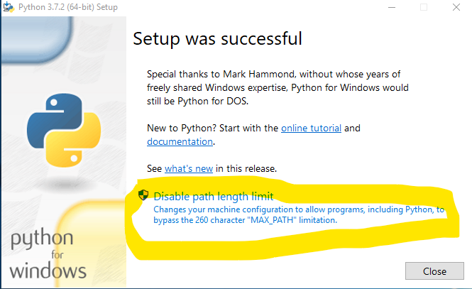

## Running someone’s Python scripts in a terminal

Often you can find scripts that someone has already written that suit your purpose. You could paste their script into your text editor or IDE, but you can also run their script directly from a file. We will do that (question 5 below) using the caesarCipher.py script from CrackingCodesFiles.zip. I recommend you make a directory for your python projects and put the extracted files fromCrackingCodesFiles.zip in it.

Download the file, caesarCipher.py, from Canvas, unzip it, and put the contents into a convenient directory. In Ubuntu I used /home/{myUserName}/python/caesarCipher.py.

In Windows, I used C:\Users\{myUserName}\python\ceasarCipher.py

Then you can run those scripts from the command line like this.

Linux  
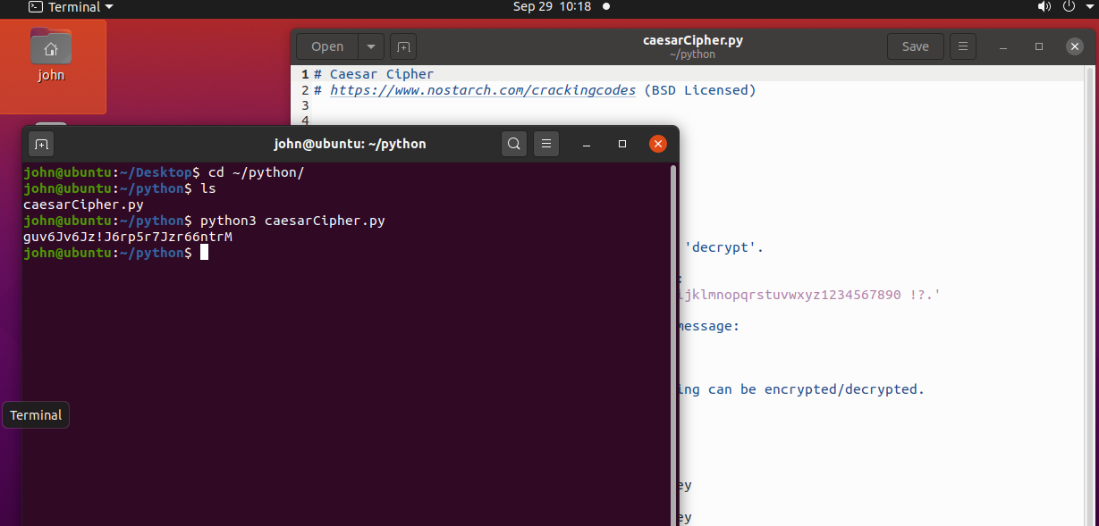  
Note: Ignore the error about pyperclip--it’s not installed on this VM (sometimes I forget to remove that from the original caesarCipher.py file.) The script ran successfully and output the encrypted version of the hard-coded input, 'This is my secret message.' with a key of 13. This script is very simple; a more practical version would allow you to specify input and output files as command line arguments or pipe the input to the script.  
  
Windows  
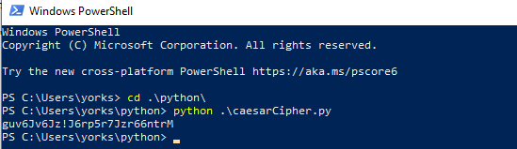

Running a Script in Idle  
Start Idle in either Linux or Windows. I’ll show Windows, but Linux is the same.

In the Idle Shell window, select File > Open.  
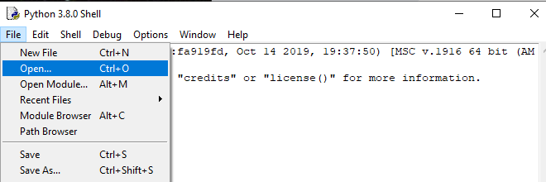

Open the file, caesarCipher.py, in this case  
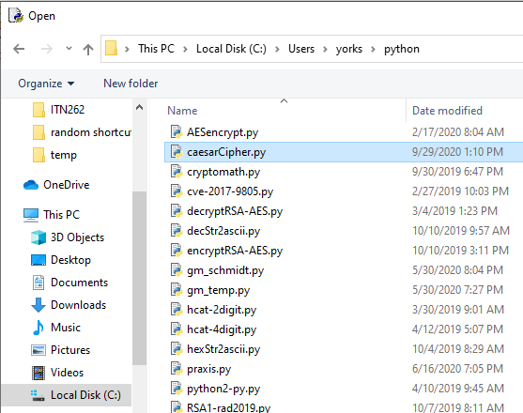  
Run the file you just opened.  
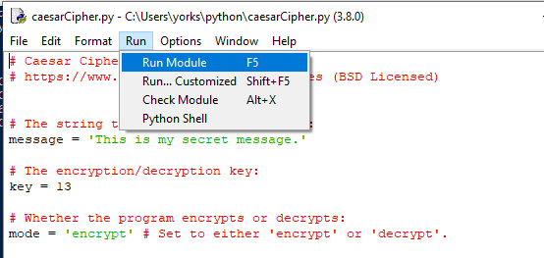

The file will run in the Shell window. If you don’t have a Shell window open, Idle will open one for you.

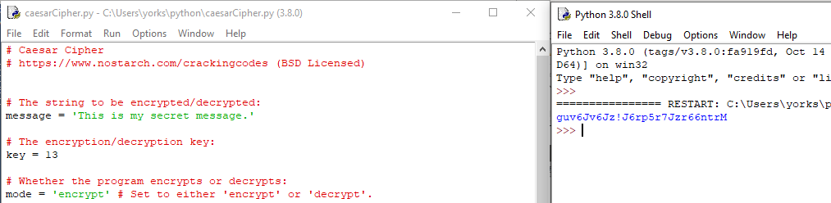

If you want to play with the Caesar cipher script, edit the code to change message (plaintext), key, and mode (encrypt or decrypt).

We will talk about how the caesarCipher.py script works later, or you can read about it in the Cracking Codes book in chapter 5, pp. 53 -68, or at <https://inventwithpython.com/cracking/chapter5.html>.

# Hand In

Chose the environment you wish to use, as explained in this document. Run the file, caesarCipher.py, in the environment you chose. Then, edit this line  
  
so that it only contains capital letters; remove the lower case, numbers, and symbols. Use the new version you’ve created to decode this message:  
SBWKRQ LV UHDOOB FRRO  
It was encoded with Caesar cipher with a key (or shift) of 3. You’ll need to change these lines to the message just above, key of 3, and mode decrypt.

Note: caesarCipher.py is a slightly modified version of the file from the book *Cracking Codes with Python*, by Al Sweigart. We will be using it in our cryptography section.